
All the Aces

Arrange 16 playing cards in a chessboard formation. Choose a “line”, either horizontal or vertical. Then “fold” along that line, as though you were folding a piece of paper.

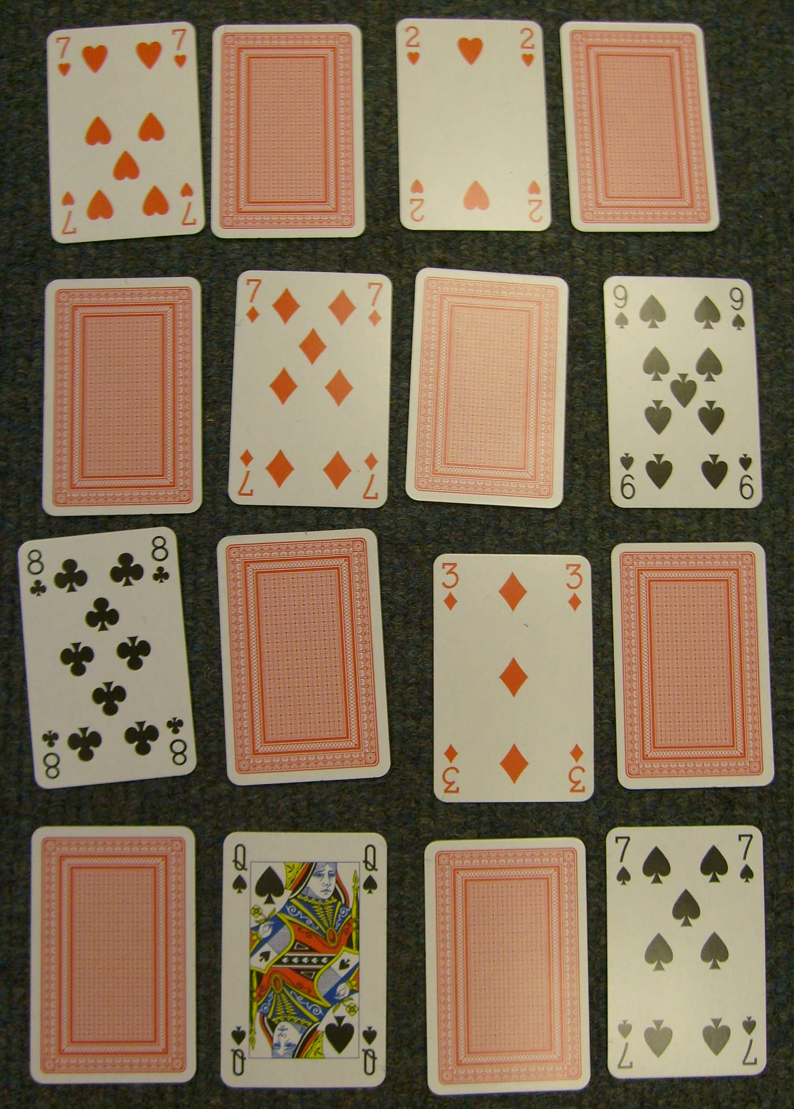

Keep choosing lines to fold along, until you have folded up the whole pack. You should find that whatever way you have folded up the pack, all the cards end up facing the same way. This trick relies on the principle that whenever you fold up a chessboard of cards (try different sizes), they will always end up facing the same way.

Now replace four of the upturned cards with Aces:

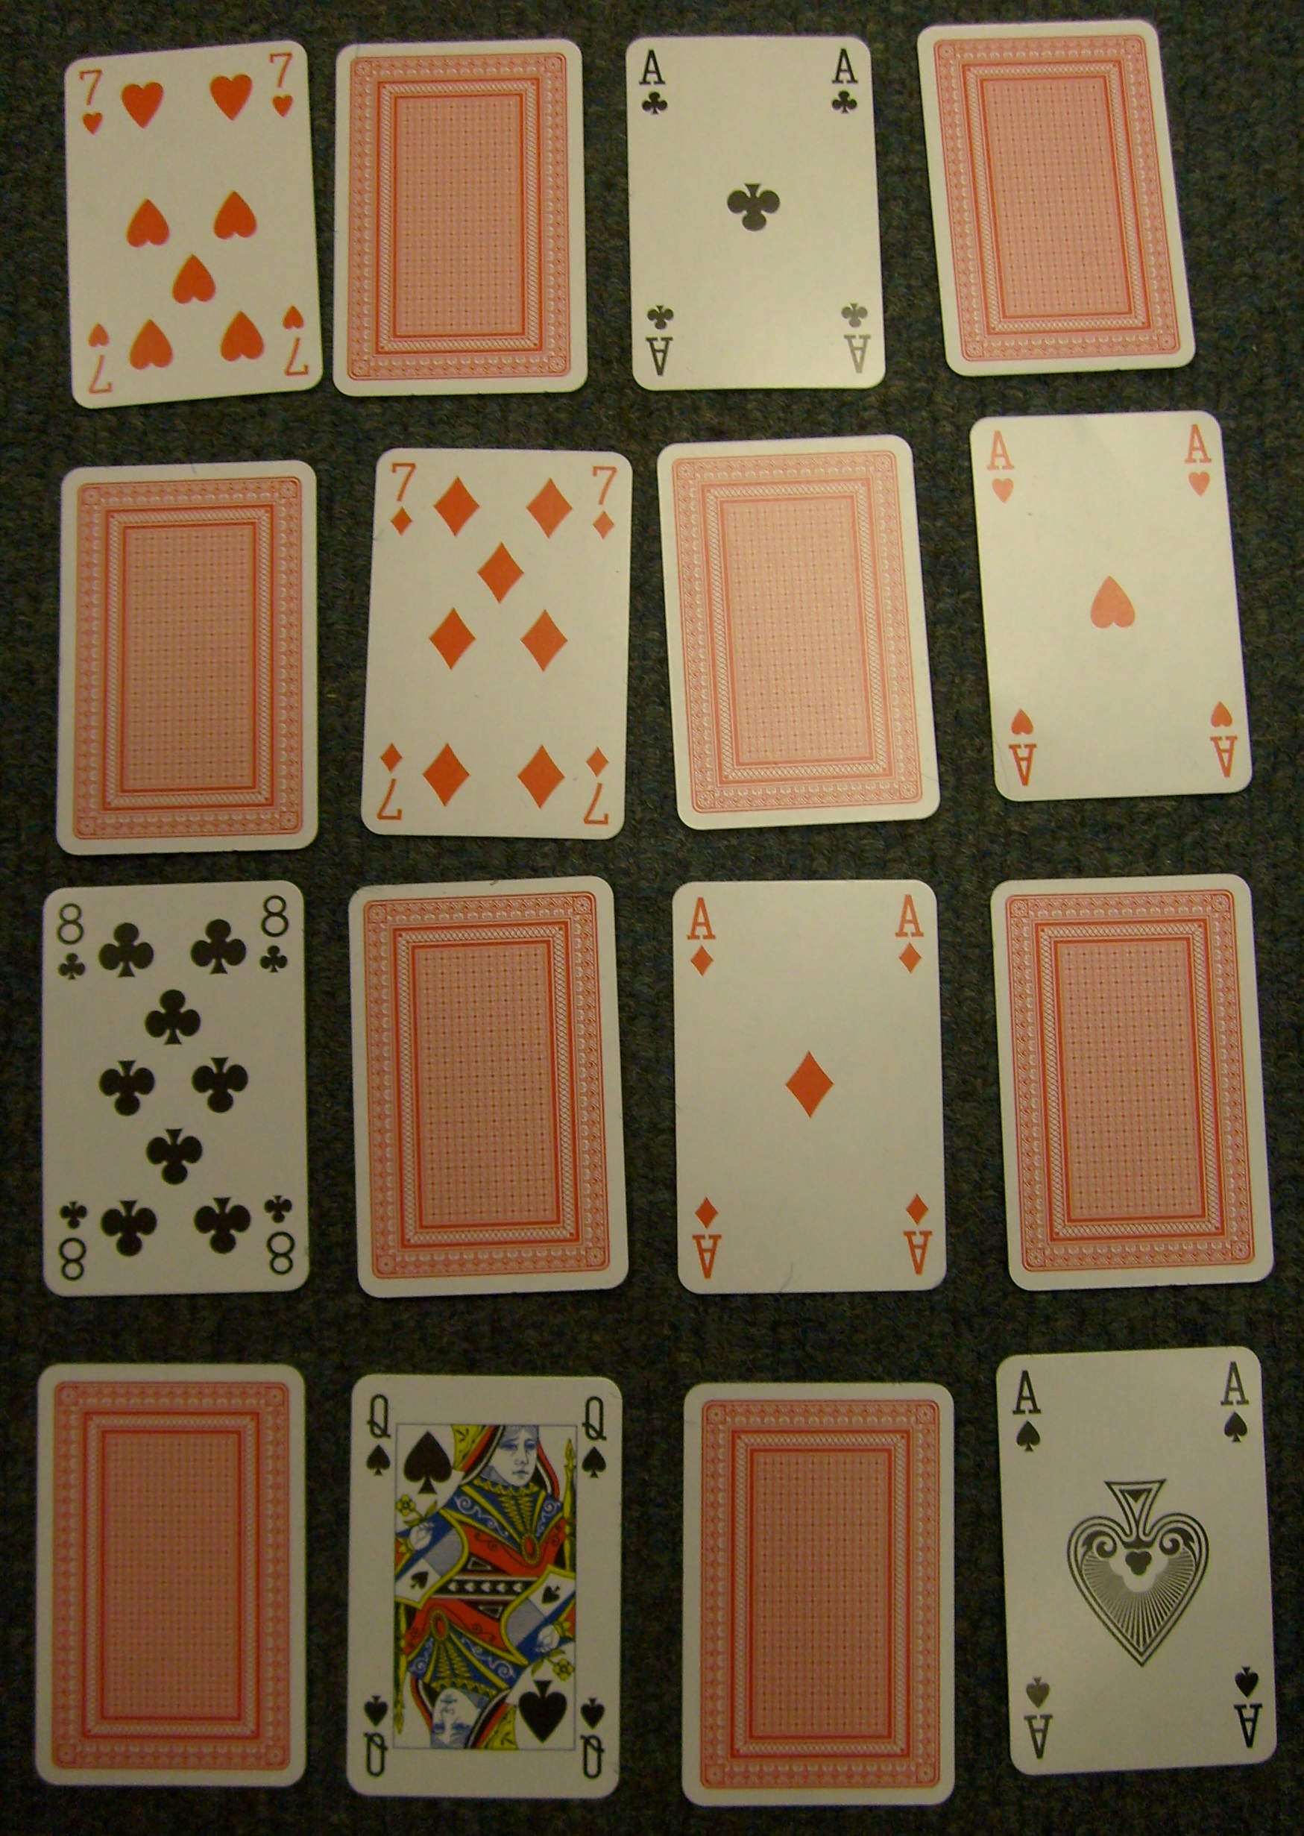

Now turn these aces over.

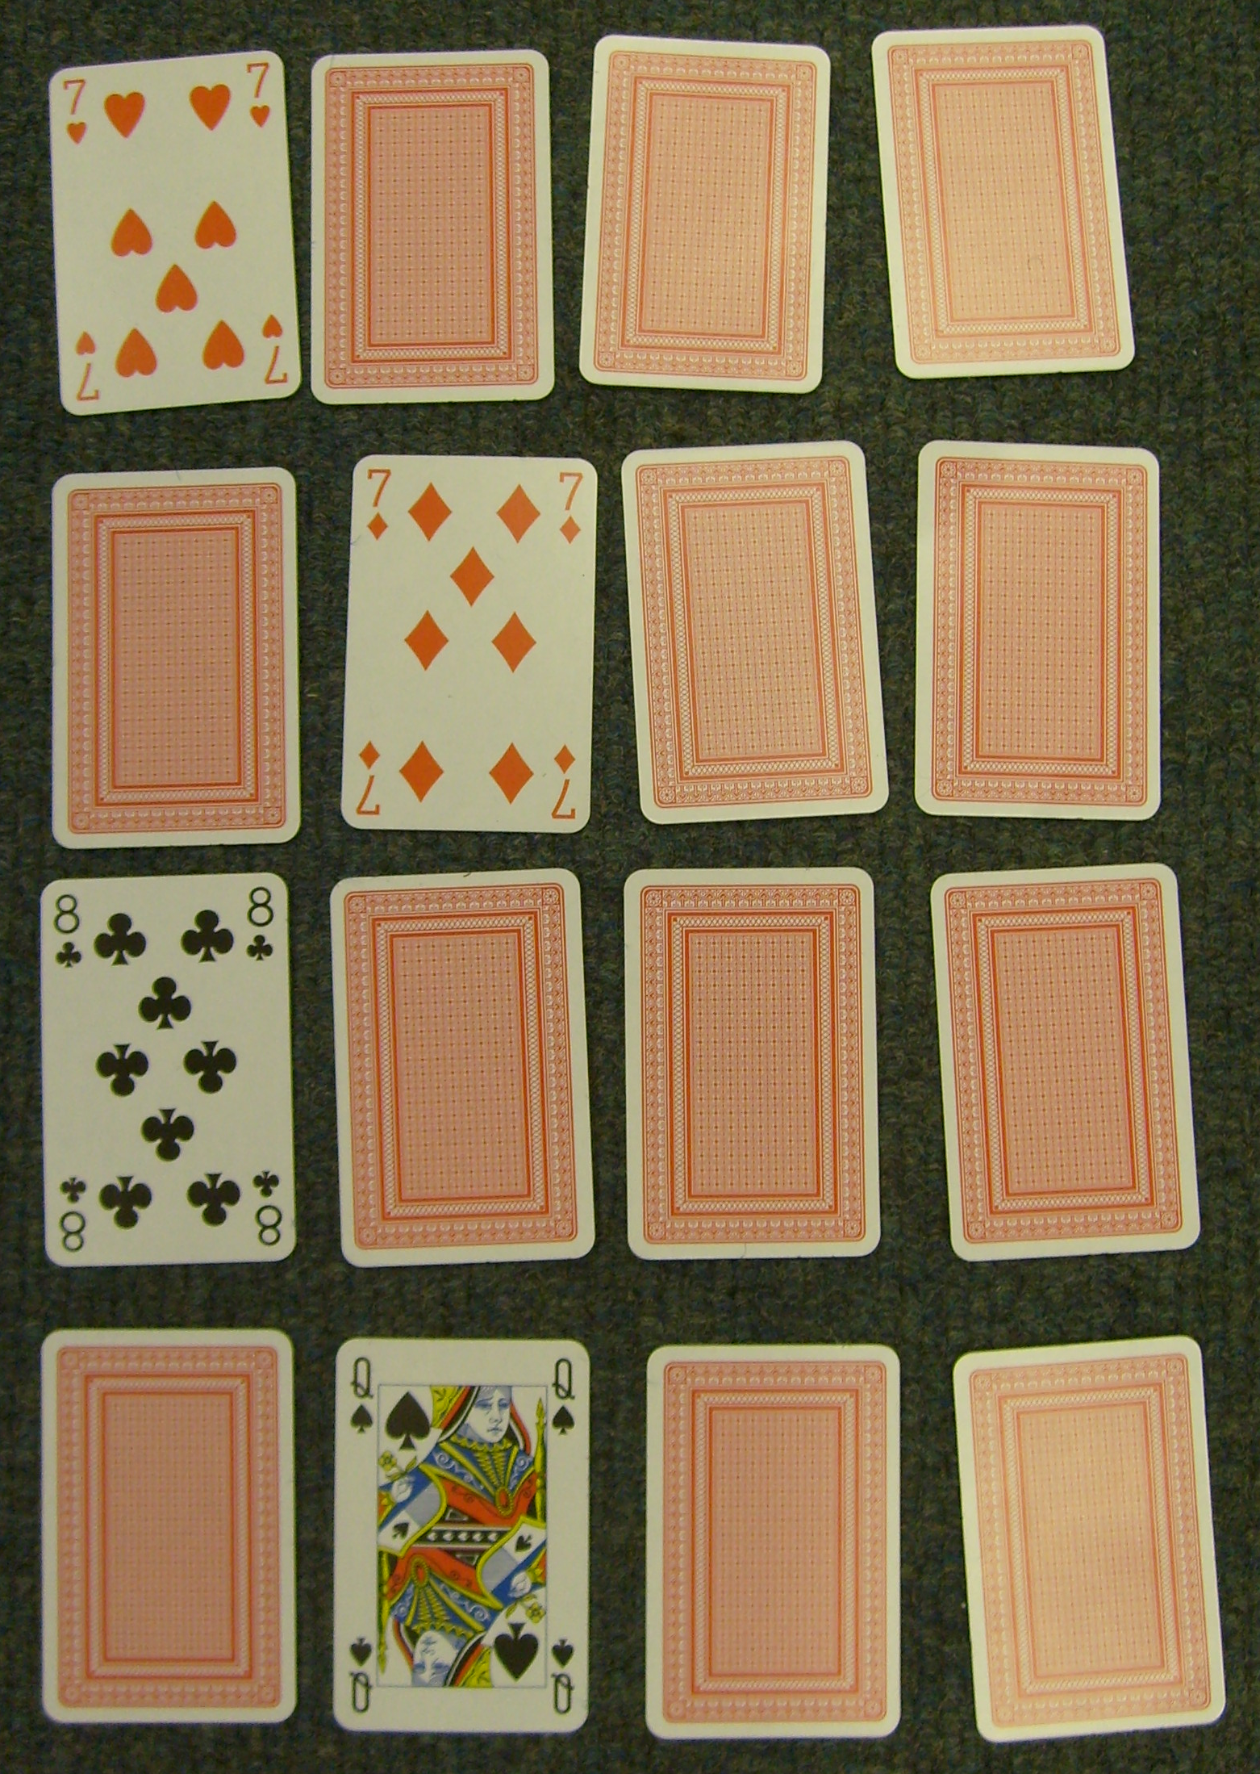

The idea is to prearrange the pack. Here this has been done with the Aces in the 3rd, 8th, 11th, and 16th positions. Then if you deal out the pack left to right, top to bottom, you can “randomly’ turn over cards 1,6,9 and 14. When you fold up the pack, the Aces will be facing the “wrong” way.

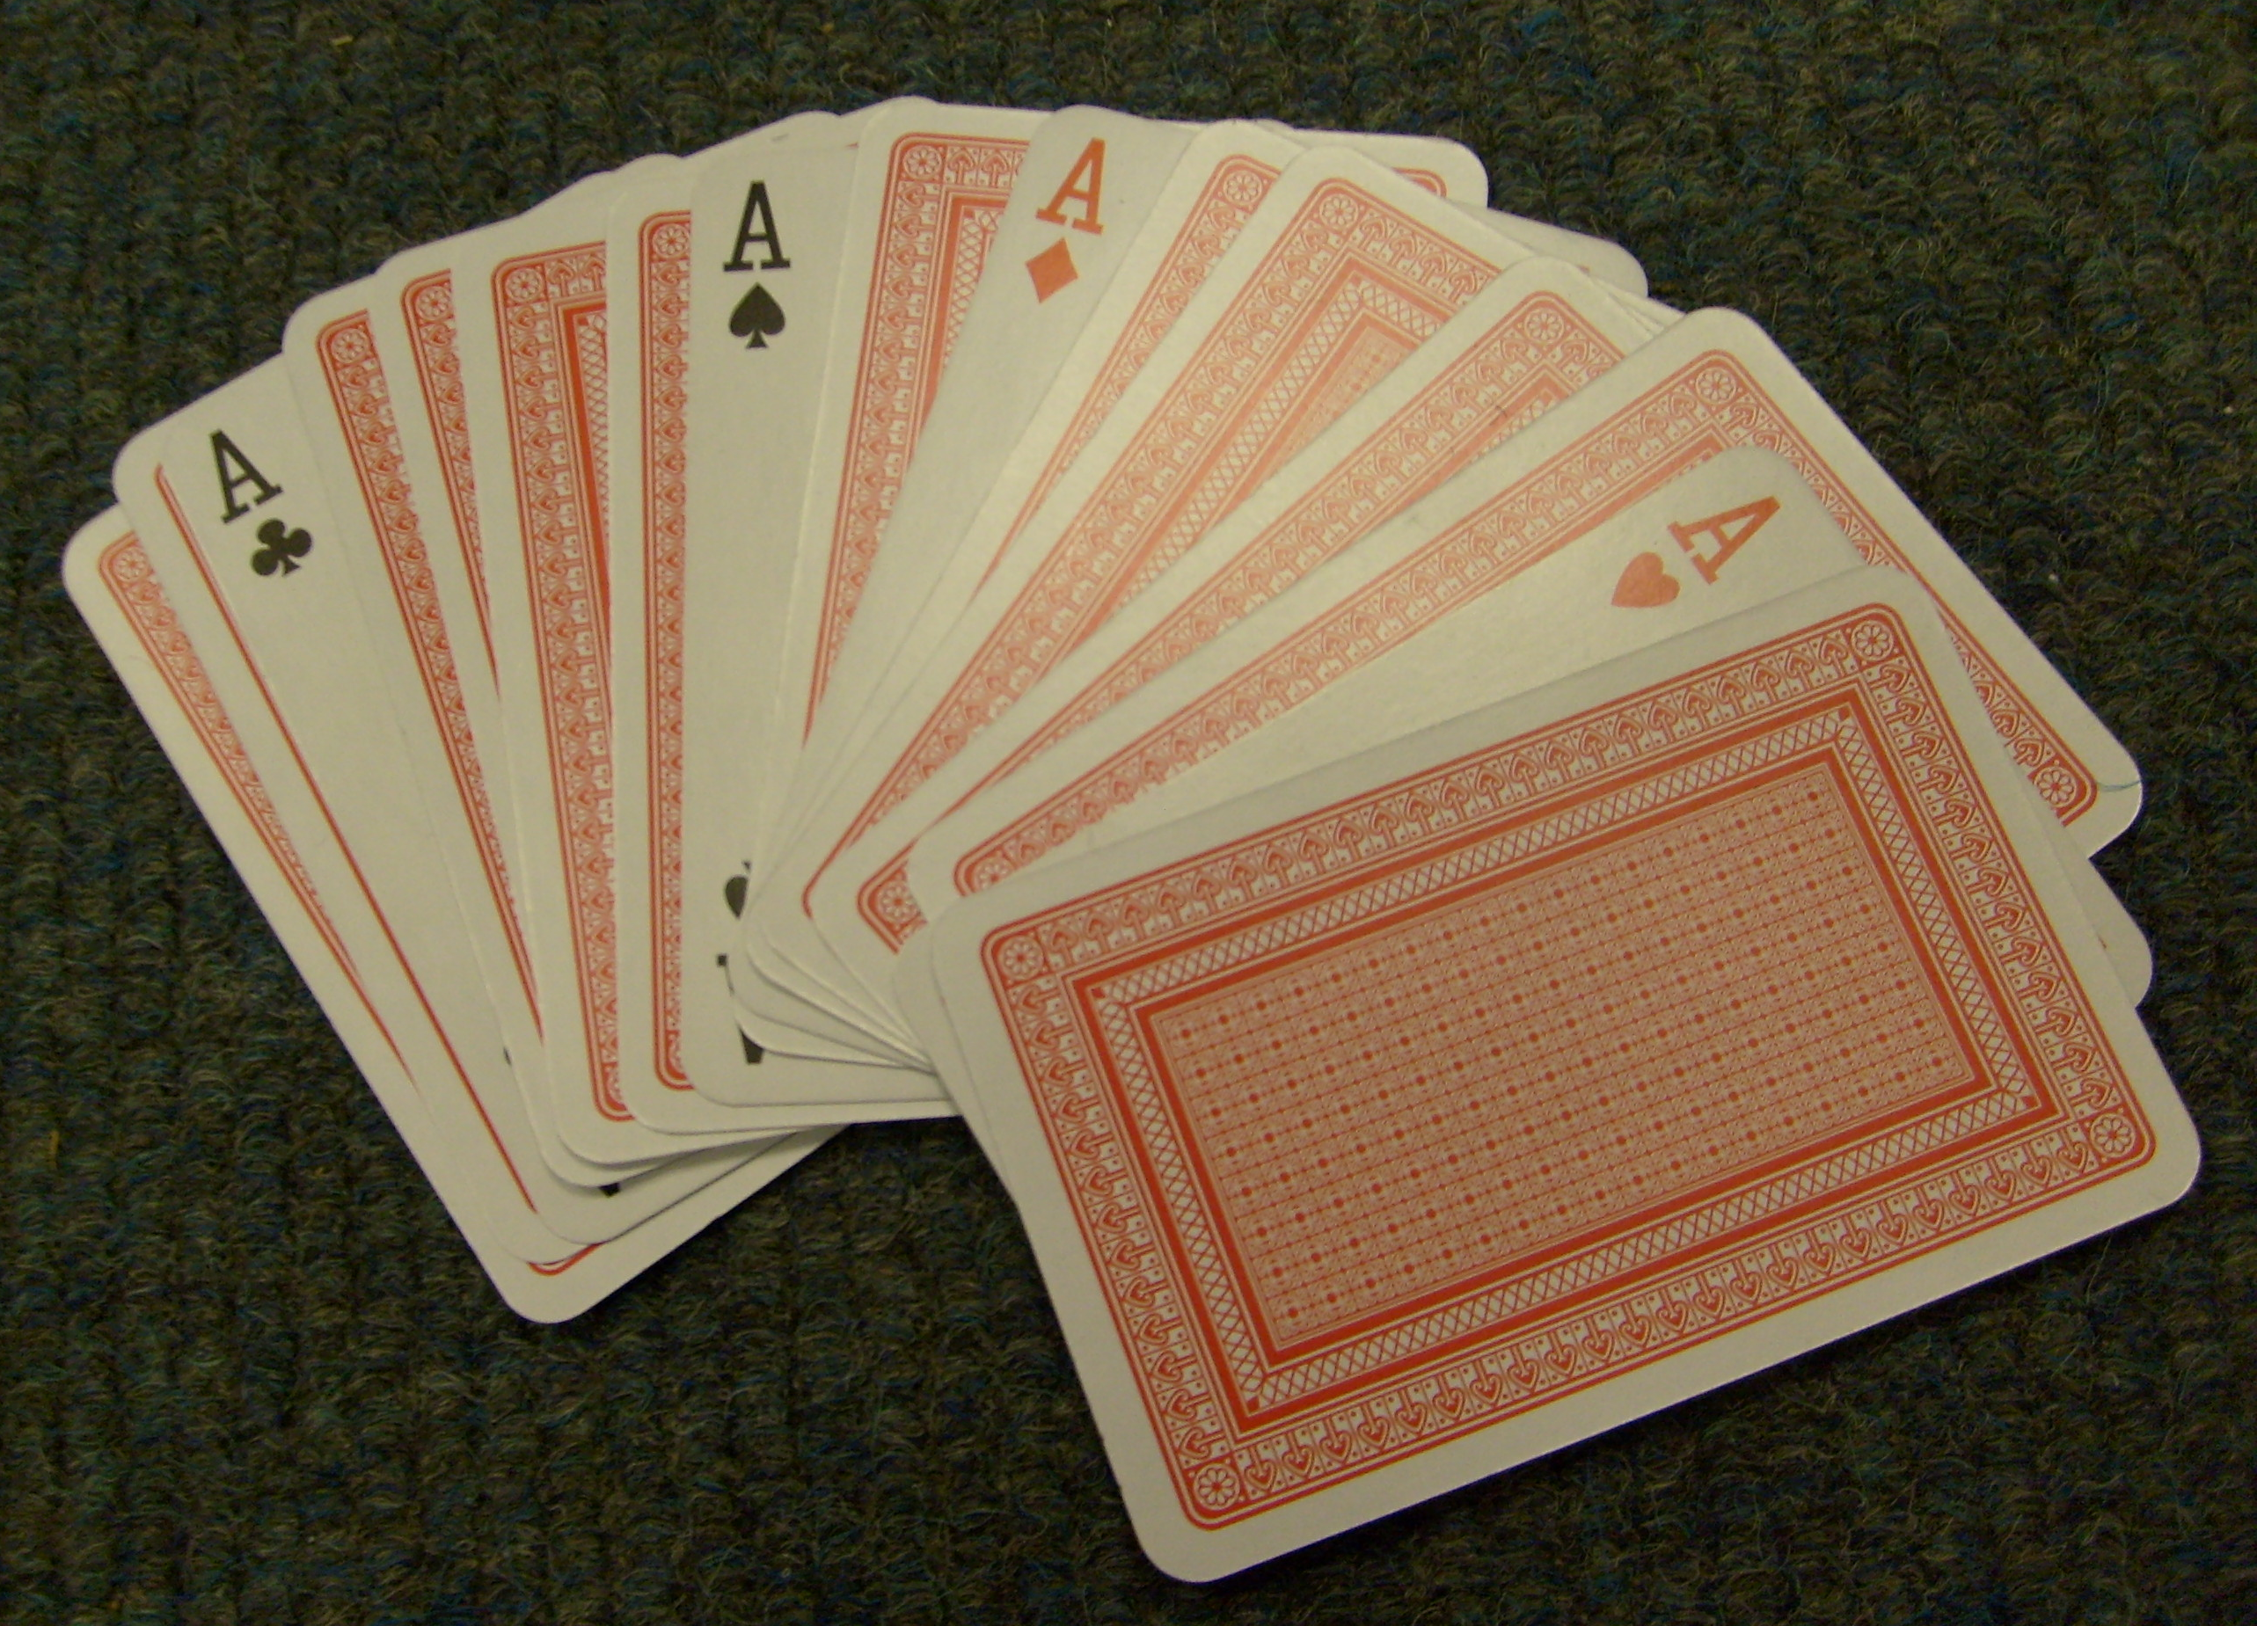

You have “magically” turned the four upturned cards into Aces.

Get the pupils to think about why folding up a chess board will always end up with all the cards facing the same way.
The idea for this trick was given to us by Rob Eastaway (www.robeastaway.com)

